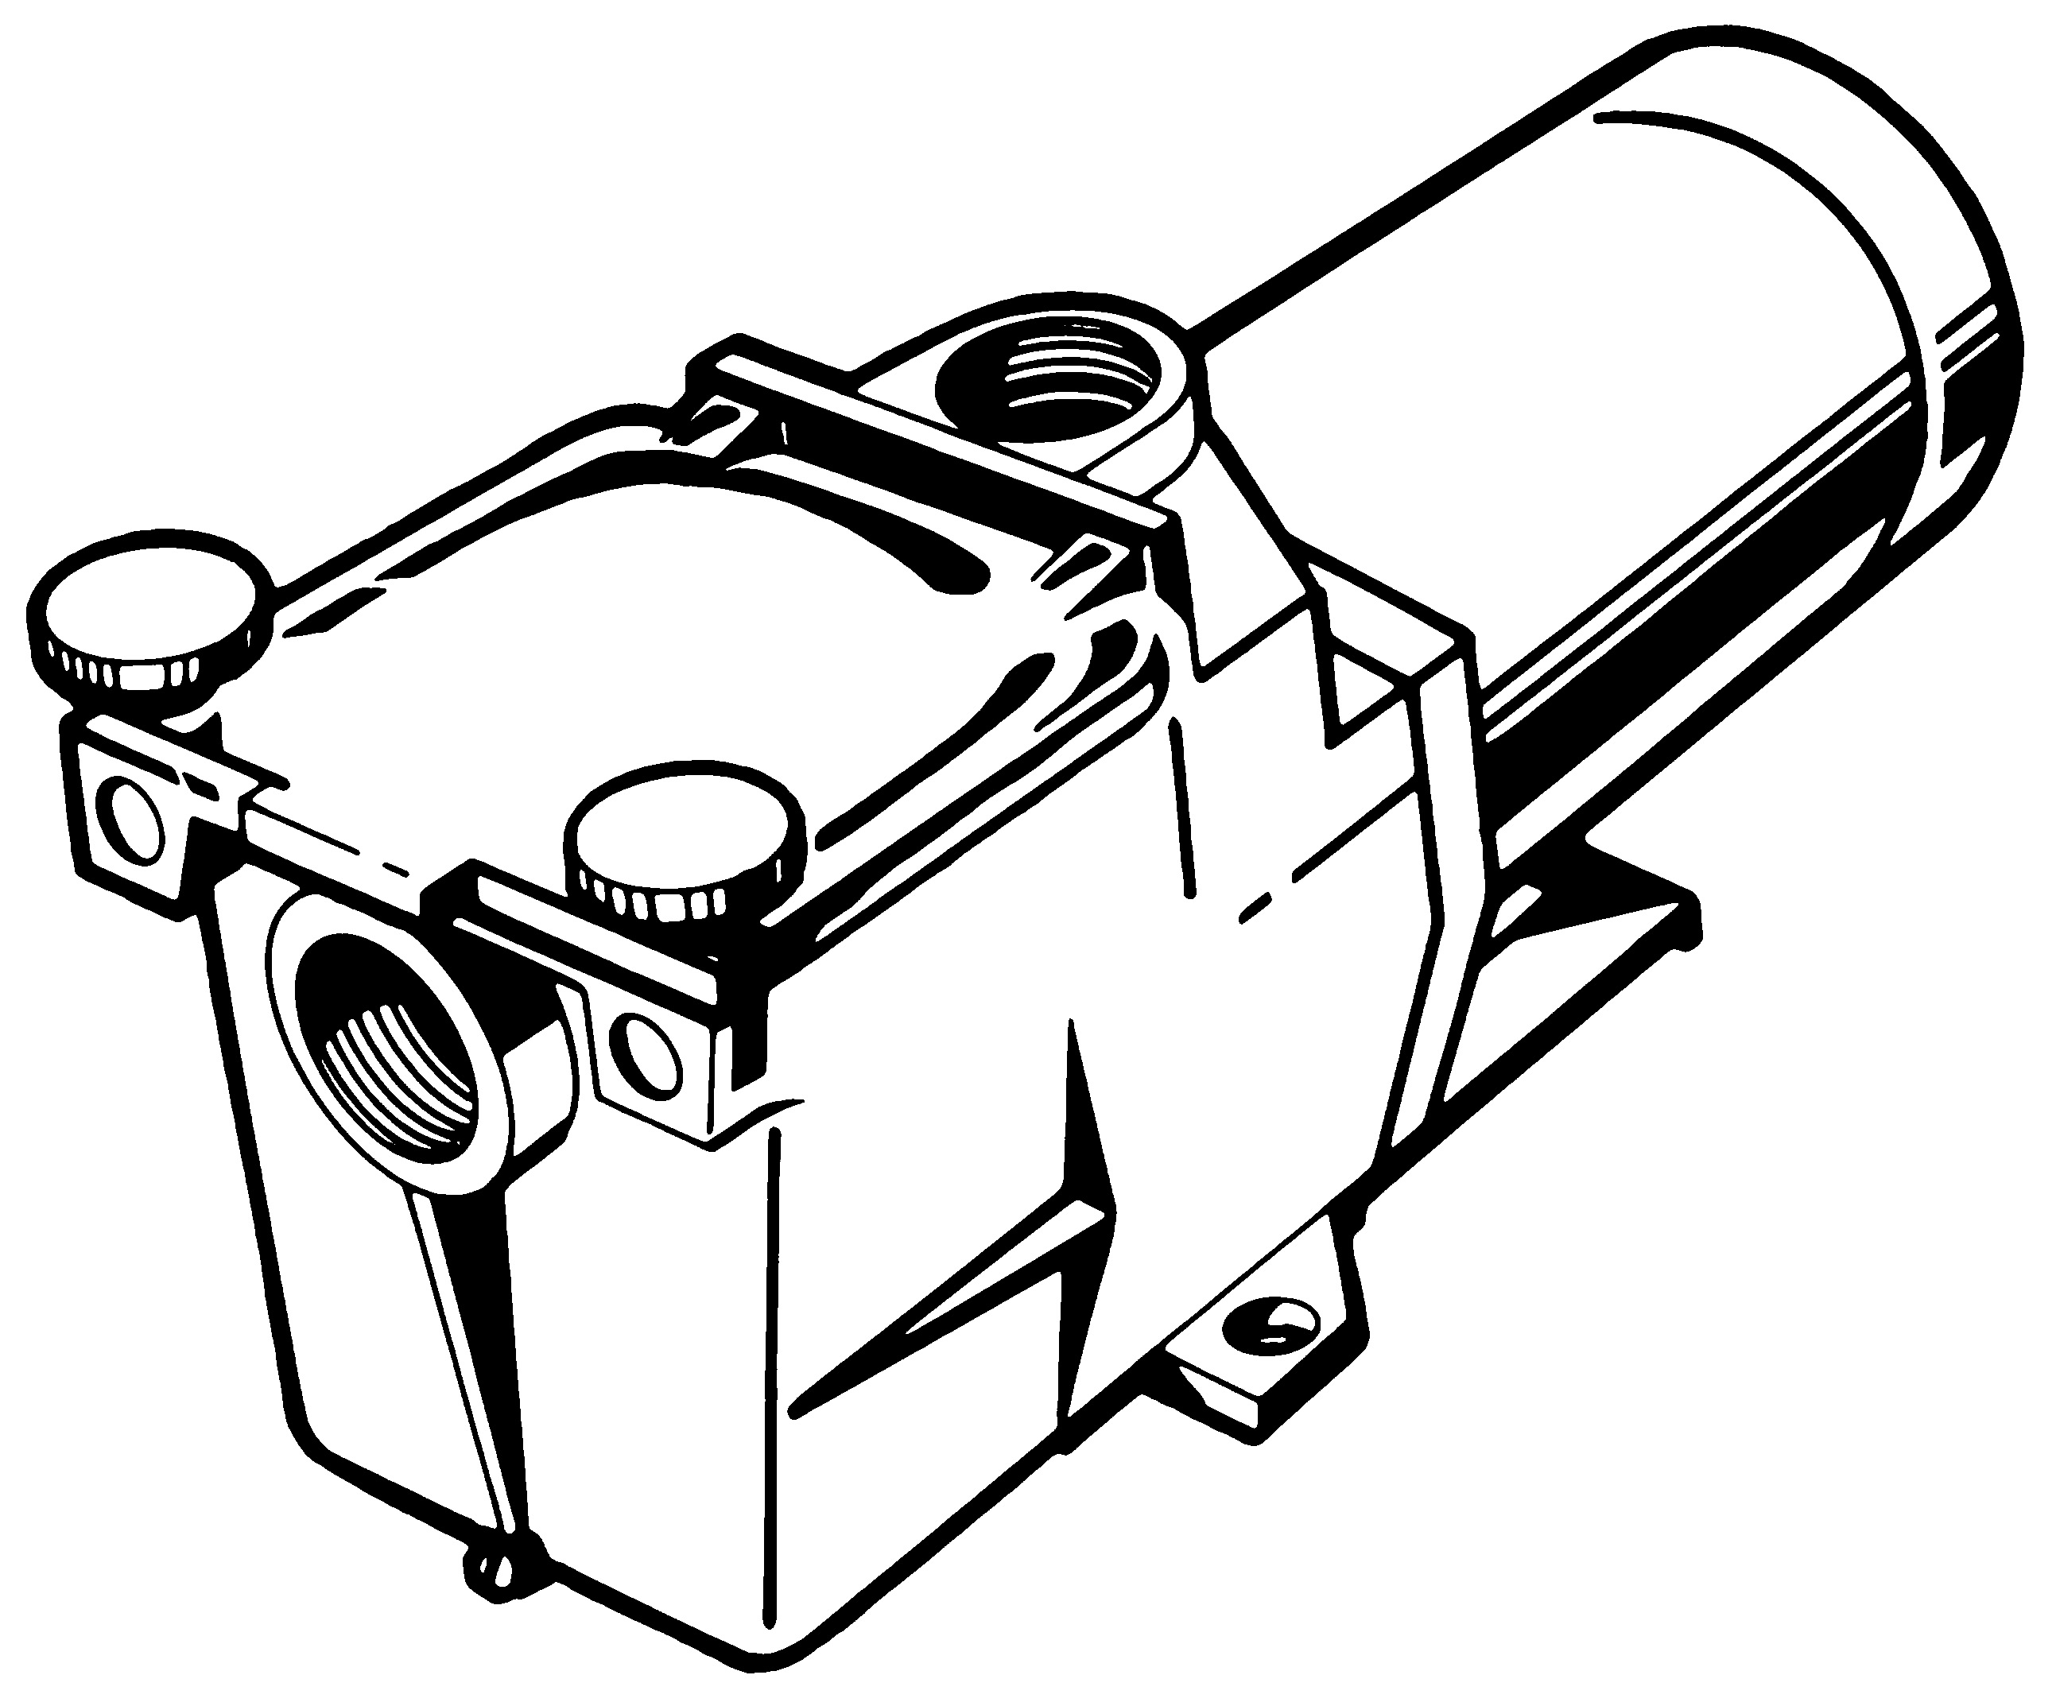
BLUE LAGOON SWIMMING POOLS L.L.C.
Swimming Pool Equipments & Accessories
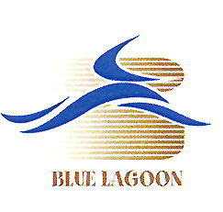
#1 Stockiest of Hayward Pool Products in UAE
Offers low prices and immediate delivery on America’s best name in pool equipments

>>>> EXPORT ORDERS WELCOME <<<<
Export orders can be shipped from Blue Lagoon’s Hamriyah Free Zone facility

HAPPY NEW YEAR

JANUARY ’2014 SPECIALS!!!
Special promotional prices and opportunities
Exclusively from Blue Lagoon Swimming Pools

COLORLOGIC LED POOL
& SPA Lighting - Made in USA

From Hayward Pool Products
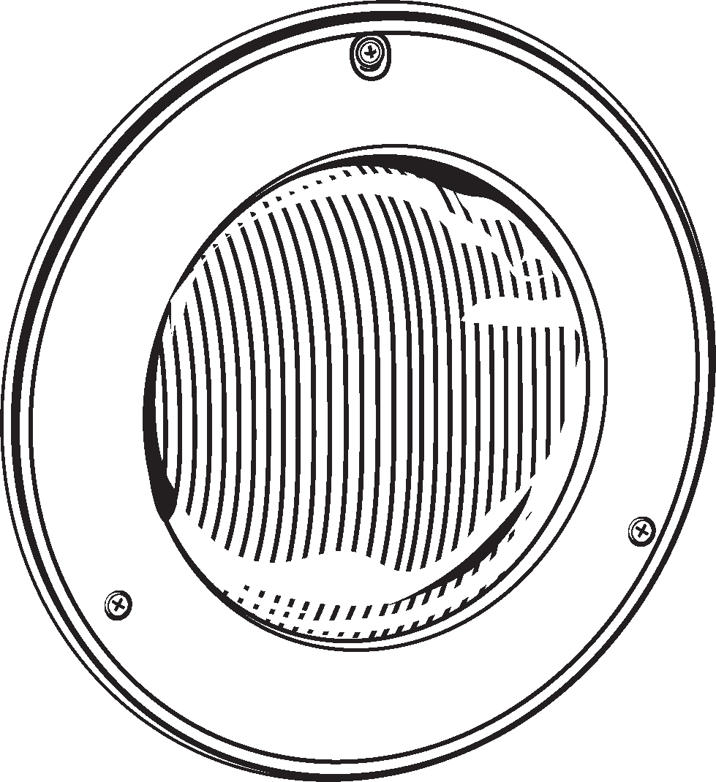
Colorlogic Pool and Spa lighting offers a revolutionary slim profile and easy-to-install product design. Most energy efficient colored lighting technology. No other pool light offers so many quality features to deliver such long lasting performance
.
HAYWARD™

TIGER SHARK ROBOTIC POOL CLEANER
High Quality components and Top Access filtering elements. This floor-specific cleaner delivers performance and price in a uniquely robust design
Standard Features
Family of robotic cleaners
Low cost, high quality performance
Quick clean technology
Requires no hoses
Requires no additional
Floor specific technology (Made in USA)
It clean most shape and size pools.

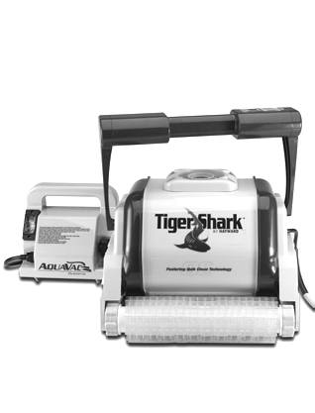

SPECIAL DEAL

ACL® 90 Chlorinating 200 gmsTablets
Trichloro Isocyanuric Acid (TCCA)
(Made in USA)
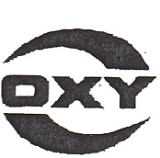
HAYWARD™

STAR-CLEAR CARTRIDGE FILTER
Star-Clear cartridge filters provide crystal clear water and have extra cleaning capacity to accommodate pools and spas of all types and sizes.
Standard Features
Single locking knob
Attractive, durable head may be
- rotated to conveniently position
Pressure gauge and manual air relief
Injection-molded filter tank depend
-able, corrosion free performance
Extra large cartridge element
Compressor overload protection.
(Made in USA)

